# **Spring Boot**

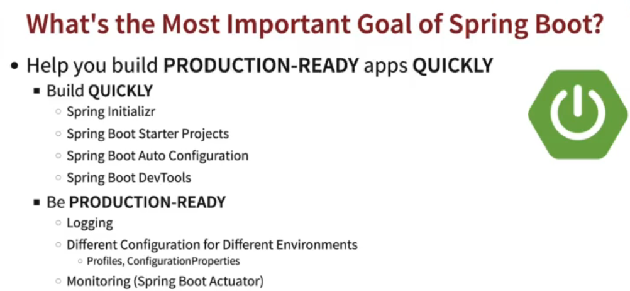

## **Autoconfiguration**

Spring boot provides several auto configurations to make life easier with spring framework.

* In **spring boot autoconfigure jar** all the autoconfigure classes are there

Apart from auto config if someone wants to configure something manually we can so that also in spring boot.



In application.properties we can specifically configure that org.springframework package should have debug logging level

If we put our application on debug we can see autoconfiguration report

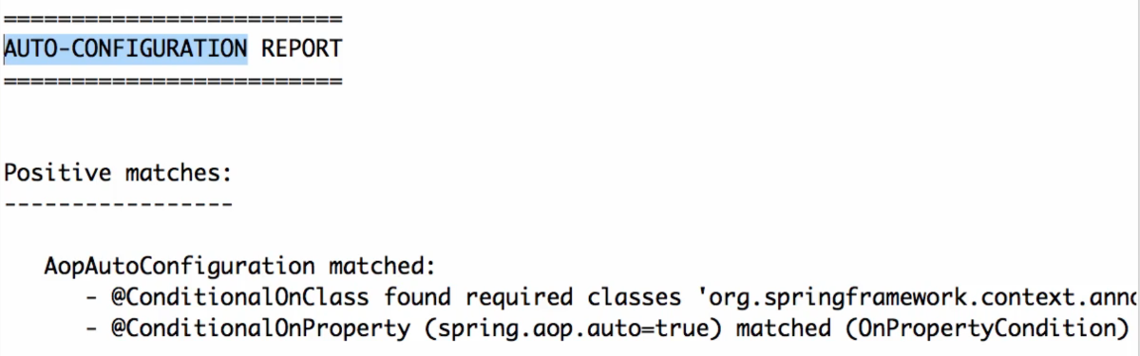

Spring boot autoconfiguration check if there is h2 in classpath it automatically configures it

When it sees web app in class path it automatically configures dispatcher servlet

When it sees a jpa in the class path it configures entitymanager and transaction manager

**What happens if you create a class outside of spring boot base package?**

Component scan will not able to pick it up automatically, you have to dedicatedly declare it using **@ComponentScan**

**Exclude a class from Auto-Configuration**

@Configuration @EnableAutoConfiguration(**exclude**={JdbcTemplateAutoConfiguration.class}) public class EmployeeApplication { public static void main(String[] args) { ApplicationContext context = SpringApplication.run(EmployeeApplication.class, args); // ... } }

**Difference between @ComponentScan and @SpringBootApplication**

Both registers beans

But componentscan scans class path and specified package and it’s subpackage for components.

We can define which packages to scan

@Configuration @ComponentScan(**basePackages** = {"com.baeldung.annotations.componentscanautoconfigure.healthcare", "com.baeldung.annotations.componentscanautoconfigure.employee"}, basePackageClasses = Teacher.class)

public class EmployeeApplication {

public static void main(String[] args) {

ApplicationContext context = SpringApplication.run(EmployeeApplication.class, args); // ... } }

The @EnableAutoConfiguration annotation enables Spring Boot to auto-configure the application context. Therefore, it automatically **creates** and registers beans based on both the **included jar** files in the classpath and the beans defined by us.

## **Profiles**

Spring Boot provides **profiles** - different environments need different configuration for the same application, for the same code

Suppose in prod you need a different profile than dev

we can have different configurations by defining different application.properties

for dev application-dev.properties <= application.properties is copied and appended with -dev for dev profile

for dev application-prod.properties <= application.properties is copied and appended with -prod for prod profile

in main application.properties you have to define which profile needs to be activated

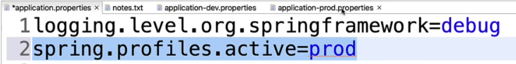

For a complex configuration approach

[Java Spring Boot Framework in 100 steps - Build a REST API and a Web application with Java, JPA, SpringBoot and Maven](https://cognizant.udemy.com/course/spring-boot-tutorial-for-beginners/learn/lecture/32995520#overview) - 16 step 10

Define configurations in application.properties and use it in the application

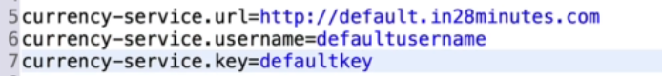(application.properties)

**CurrencyServiceConfiguration.java**

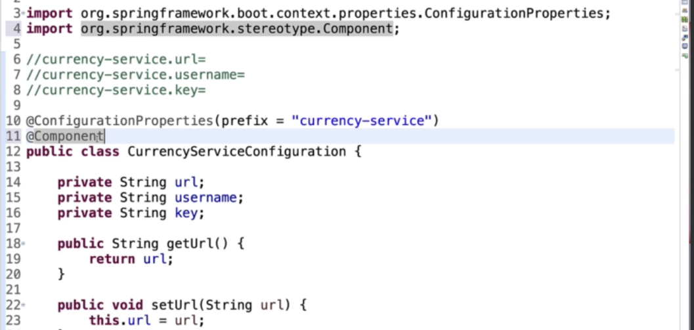

To get configured we can just use a rest controller

**CurrencyConfigurationController.java**

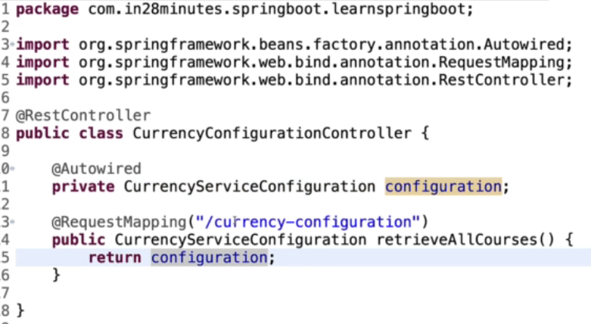

**@component** and **@autowird** also mentioned in this video why we use it.

## **How can you simplify deployment with spring boot ?**

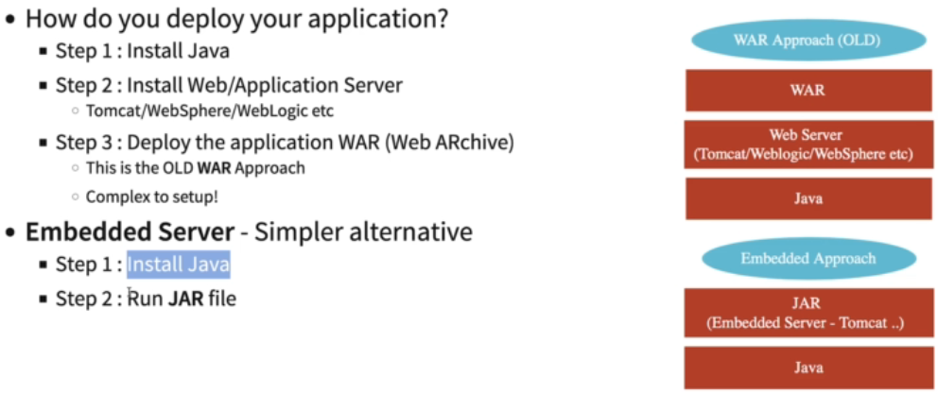

Earlier to deploy n application you need to install java then install a web application like tomcat and deploy that jar/war

**In spring boot web server is a part of your jar file**

## **SpringBoot Actuator**

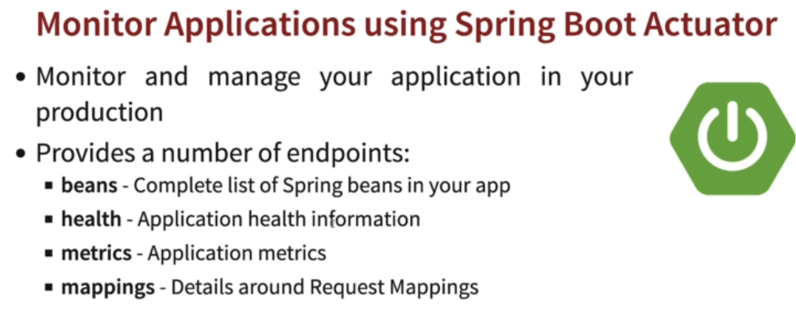

Spring boot actuator helps you to monitor your application like it’s running or not, beans configured or not….

helps you to monitor and manage your application when you push it to production. These actuators include auditing, health, CPU usage, HTTP hits, and metric gathering, and many more that are automatically applied to your application

To use actuator add dependency in pom.xml for actuator

In **application.properties** mention the endpoints that you want to check

 <= to expose all the endpoints use * or beans, heath to specify the endpoint.

From browser hit actuator url like locahost:8080/acruator

------------------------------------------------------------------------------------------------------------------------------------------

Use server.port = 8081 to change default port number in application.properties

SecureRandom class to generate random sequence.



## **Change application properties name in spring boot**

@SpringBootApplication

public class MyApplication {

public static void main(String[] args) {

// Tell Boot to look for my-project.properties instead of application.properties

**System.setProperty("spring.config.name", "my-project");**

SpringApplication.run(MyApplication.class, args);

}

}

## **Use of Developer tools in spring boot?**

It provides fast application restart, live reload, configuration for faster development.

## **H2 Database**

By default H2 database creates a random data source. To have a custom datasource you need to configure it in application.properties.

Spring.datasource.url =

Get to know about architectures : subscribe publisheder model, topic/queue

Create a database during initialization using **schema.sql** file

Please note that for any script-based initialization, i.e. inserting data via data.sql or creating schema via schema.sql, we need to set the below property:

**spring.sql.init.mode=always**

For embedded databases such as H2, this is set to always by default.

**Difference between JDBC and Spring JDBC**

With spring jdbc we have write less number of code

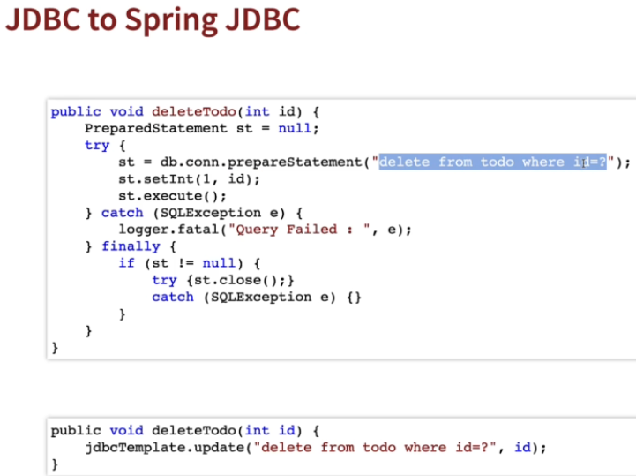

In spring jdbc we don’t have to manage our connections opening and closing

## **JdbcTemplate**

In jdbc template to map query returned value with the pojo class object we useBeanPropertyRowMapper<>(class)

**new** BeanPropertyRowMapper<>(GuestVo.**class**)

jdbcTemplate.queryForObject(SELECT_GUEST, new BeanPropertyRowMapper<>(GuestVo.class), guestID);

**Commandlinerunner** is implemented in spring boot to run that code during start up of server

In spring jpa to show the sql statements generated internally we can use **spring.jpa.show-sql** = true;

**Difference between Spring JPA and SpringData Jpa:**

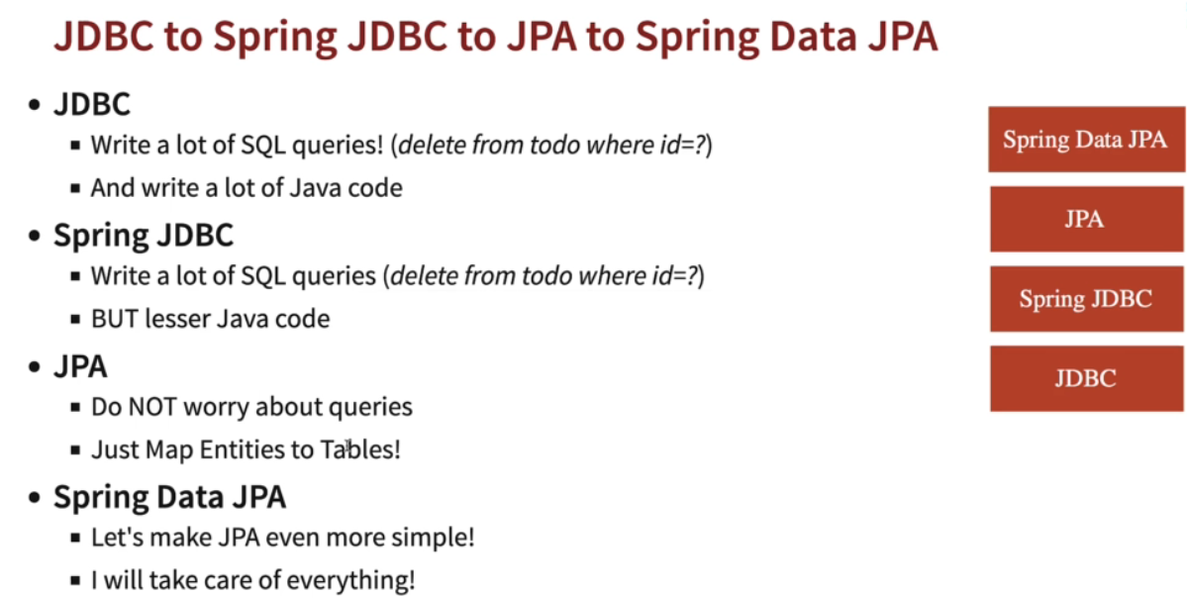

With SpringDataJpa it’s more simplified that we don’t have to even manage the entity manager now, just create and interface and extend JPA repository interface.

package com.springJPA.JPA.jpaRepo;

import org.springframework.data.jpa.repository.JpaRepository;

import com.springJPA.JPA.Guest.GuestVo;

public interface Guestrepository extends **JpaRepository**<GuestVo, Integer>{

}

JpaRepository is an interface, we need to create an repository and extend this interface to use all of it’s methods.

JpaRepository takes first parameter as class name and primary key type of the table, in this case it’s Integer

@Component

public class GuestCommandLineRunner implements CommandLineRunner{

@Autowired

private Guestrepository guestRepo;

@Override

public void run(String... args) throws Exception {

System.out.println(".........................working......................");

guestRepo.save(new GuestVo(120, "Ank", 7908181658L, "vilai"));

guestRepo.save(new GuestVo(121, "Lisha", 7908181658L, "chennai"));

System.out.println(guestRepo.findById(121));

System.out.println(guestRepo.findAll());

guestRepo.deleteById(120);

}

}

What is JPA?

Spring Boot JPA is a **Java specification** for managing relational data in Java applications. It allows us to access and persist data between Java object/ class and relational database. JPA follows Object-Relation Mapping (**ORM**). It is a set of interfaces. It also provides a runtime EntityManager API for processing queries and transactions on the objects against the database. It uses a platform-independent object-oriented query language JPQL (Java Persistent Query Language).

What is hibernate?

Hibernate is a java framework and ORM (Object Relation Mapping) tool that is used to provide the **implementation** of the JPA methods. Except hibernate we have EclipseLink which also provides implementation for JPA.

What is an Entity class?

An entity class represents a table in a relational database.

It needs to be annotated with @Entity

The class needs to have a public/protected no arg constructor.

ID generation strategies

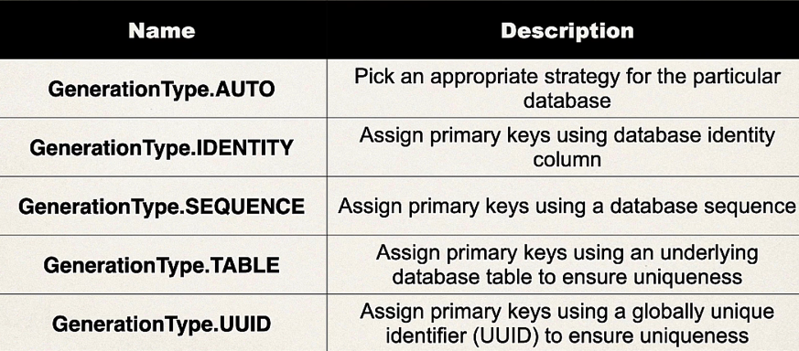

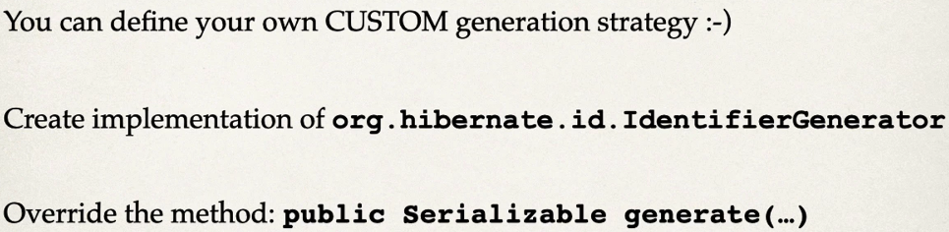

**Change name of application.properties**

@SpringBootApplication

public class MyApplication {

public static void main(String[] args) {

// Tell Boot to look for my-project.properties instead of application.properties

**System.setProperty("spring.config.name", "my-project");**

SpringApplication.run(MyApplication.class, args);

}

}

Where to use Entity manger and JPARepository?

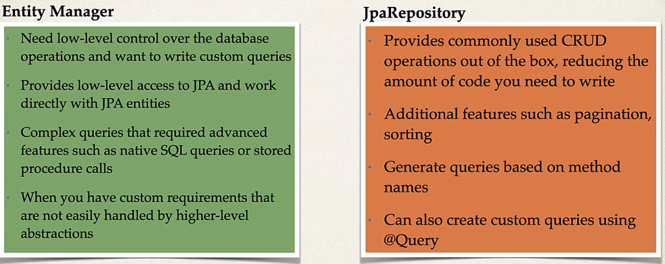

Entity manager is low level more control and JPARepository is high level less control.

Hibernate is the **default** implementation on spring data jpa, if we don’t configure any other ORM vendor hibernate provides the default implementation.

## **Id Genetors**

Jpa supports four types of Id generation strategies,

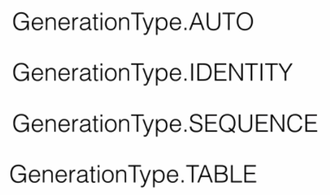

**AUTO** : checks what DB supports and selects the generation type from IDENTITY, SEQUENCE, TABLE

**IDENTITY**: it auto increments the id field, for this we have the configure the primary key with auto increment enable in DB side.

**SEQUENCE**: the ORM provider like hibernate will use the sequence generated by DB to provide the id. You need to specify along with GenerationType which **sequence to be used.**

**TABLE**: it will store the id in a **special** table and when creating a new id it will check the table and insert the new value into special table also in the id field of the required table.

@Transactional

It helps to manage the transaction while performing DB changes.

Choose Transactional from spring framework not from jakarta

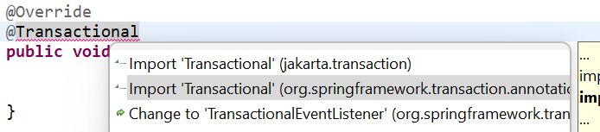

**Basic Save Data Code using Entity Manager**

**DB**

create table student (

id int not null auto_increment,

first_name varchar(10),

last_name varchar(10),

email varchar(15),

primary key(id)

)



**DAO Class**



DAO implementation class



**Commandline runner**



AUTO INCREMENT in DB creation takes care of the automatic id generation

The increment generally starts with 1,2,3…. But we can manually set start point by,

Alter table student **AUTO_INCREMENT** =3000

## **Querying Objects with JPA**

JPQL syntax is based on the entity name and fields

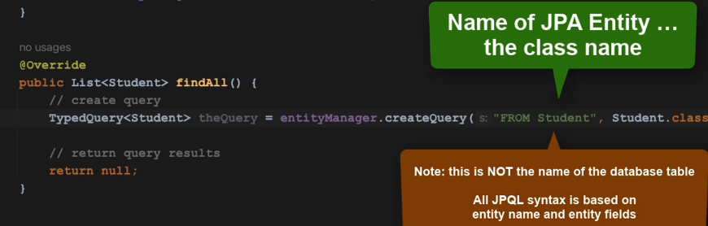

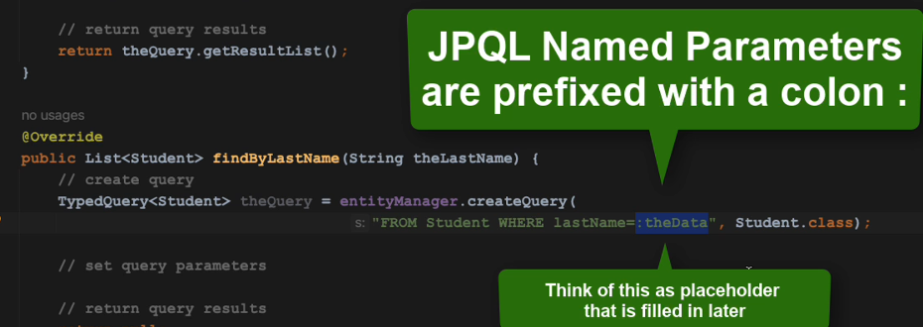

Why we need student.class as parameter for select but not for update or delete query

**Merge** method insert/save data if id==0 otherwise it updates data if id is not 0

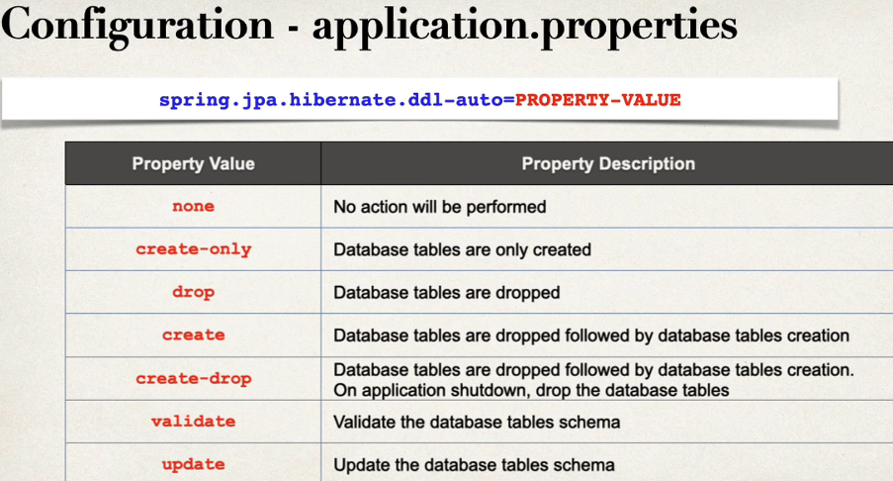

Update will not delete existing data , it will keep existing data and add new data upon that



## **FindByMultiFields**



| **Logical keyword** | **Keyword expressions** |
| --- | --- |
| AND | And |
| OR | Or |
| AFTER | After, IsAfter |
| BEFORE | Before, IsBefore |
| CONTAINING | Containing, IsContaining, Contains |
| BETWEEN | Between, IsBetween |
| ENDING_WITH | EndingWith, IsEndingWith, EndsWith |
| EXISTS | Exists |
| FALSE | False, IsFalse |
| GREATER_THAN | GreaterThan, IsGreaterThan |
| GREATER_THAN_EQUALS | GreaterThanEqual, IsGreaterThanEqual |
| IN | In, IsIn |
| IS | Is, Equals, (or no keyword) |
| IS_EMPTY | IsEmpty, Empty |
| IS_NOT_EMPTY | IsNotEmpty, NotEmpty |
| IS_NOT_NULL | NotNull, IsNotNull |
| IS_NULL | Null, IsNull |
| LESS_THAN | LessThan, IsLessThan |
| LESS_THAN_EQUAL | LessThanEqual, IsLessThanEqual |
| LIKE | Like, IsLike |
| NEAR | Near, IsNear |
| NOT | Not, IsNot |
| NOT_IN | NotIn, IsNotIn |
| NOT_LIKE | NotLike, IsNotLike |
| REGEX | Regex, MatchesRegex, Matches |
| STARTING_WITH | StartingWith, IsStartingWith, StartsWith |
| TRUE | True, IsTrue |
| WITHIN | Within, IsWithin |

In addition to filter predicates, the following list of modifiers is supported:

| *Table 3. Query predicate modifier keywords* | |
| --- | --- |
| **Keyword** | **Description** |
| IgnoreCase, IgnoringCase | Used with a predicate keyword for case-insensitive comparison. |
| AllIgnoreCase, AllIgnoringCase | Ignore case for all suitable properties. Used somewhere in the query method predicate. |
| OrderBy… | Specify a static sorting order followed by the property path and direction (e. g. OrderByFirstnameAscLastnameDesc). |

https://docs.spring.io/spring-data/jpa/reference/repositories/query-keywords-reference.html

 all the products greater than the given price

 All the products that contain the word in their descrption

findBy(model class column name)Contains() -> here findBy column name is what we will be taking as parameter





## **Paging and Sorting**

**public** List<Guest> getAllGuestsByPage(**int** pageNo) {

Pageable pageable = PageRequest.*of*(pageNo, 2);

List<Guest> guests= **new** ArrayList<>();

guests = guestRepository.findAll(pageable).getContent();

**return** guests;

}

findAll having several overloaded methods, so we can pass a pageable instance object.

PageRequest.of() returns pageable object as it implements pageable interface

PageRequest.of(**pageNo**, 2) takes two parameters, first the page no you want to fetch

Second is the no of data in each page

**Sorting**

For sorting we use soryby method .

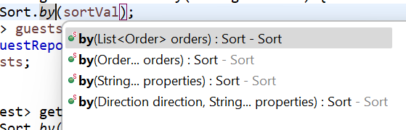

Sort.by( properties ) takes different properties as a parameter like below we can send ghName while will sort data based on ghname, by default it will sort ASC order.

**public** List<Guest> getAllGuestsSortBy(String sortVal) {

Sort by = Sort.*by*(sortVal);

List<Guest> guests= **new** ArrayList<>();

guests = guestRepository.findAll(by);

**return** guests;

}

If we want to pass **sort order** also then we have to use last overloaded method.

**public** List<Guest> getAllGuestsSortByDesc(String sortVal) {

Sort by = Sort.*by*(Direction.***DESC***, sortVal);

List<Guest> guests= **new** ArrayList<>();

guests = guestRepository.findAll(by);

**return** guests;

}

**Paging and Sorting together**

**public** List<Guest> getAllGuestsByPageAndSort(**int** pageNo, String sortDir, String sortVal) {

Direction direction = Direction.***ASC***;

**if**(sortDir.equalsIgnoreCase("DESC"))

{

direction = Direction.***DESC***;

}

Pageable pageable = PageRequest.*of*(pageNo,2,Sort.*by*(direction,sortVal));

List<Guest> guests= **new** ArrayList<>();

guests = guestRepository.findAll(pageable).getContent();

**return** guests;

}

**Paging and Sorting on a custom finder method**

GuestRepository.java

**public** List<Guest> findByGhName(String ghName,Pageable pageable);

GuestServices.java

**public** List<Guest> findByGhName(String name)

{

**return** guestRepository.findByGhName(name, PageRequest.*of*(0, 2));

}

**How to handle SpringDataJpa exceptions ?**

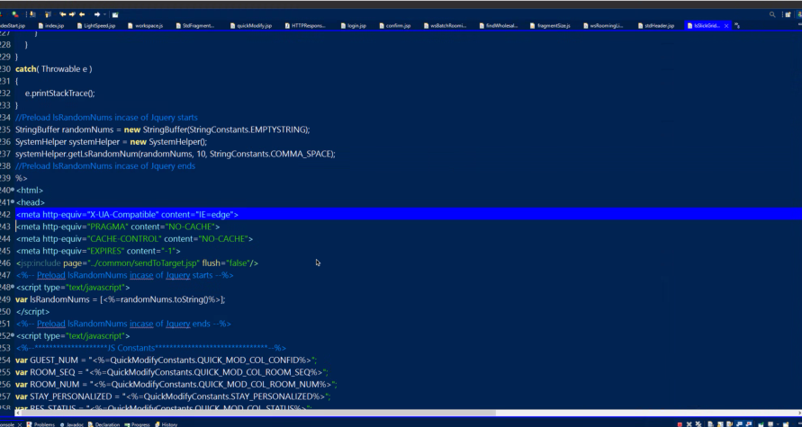

Meta tags

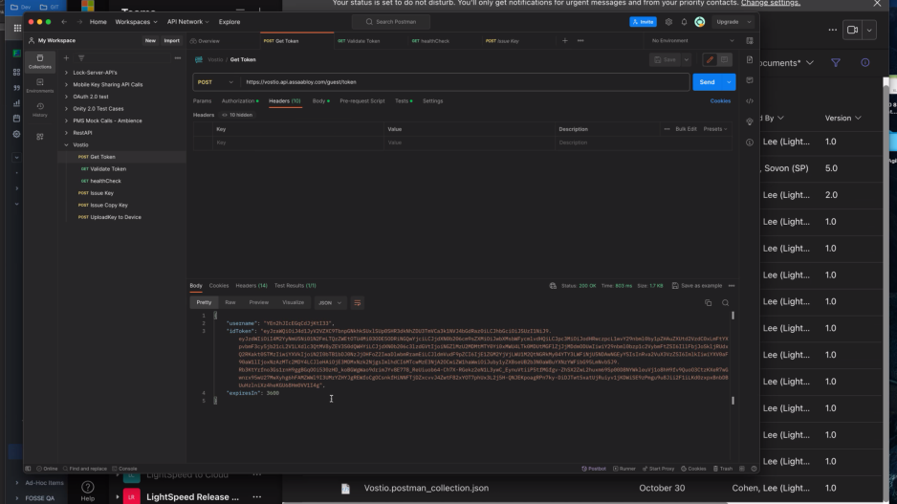

# **REST**

REST stands for representational state transfer

Why REST is called representational state transfer ?

**REST** is **language independent**, if you want to use an weather app api to get weather info, you can get it over HTTP irrespective of in which language the weather server is written and how clients apps are communicating.

@RestController = 1. **@Controller @ResponseBody**

**Path variable**

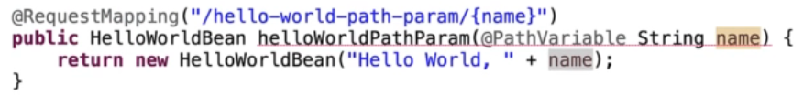

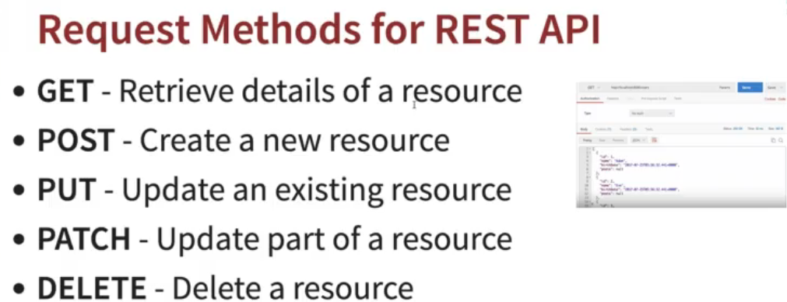

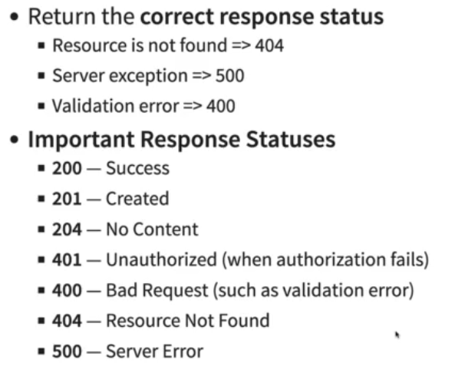

## **Data Binding**

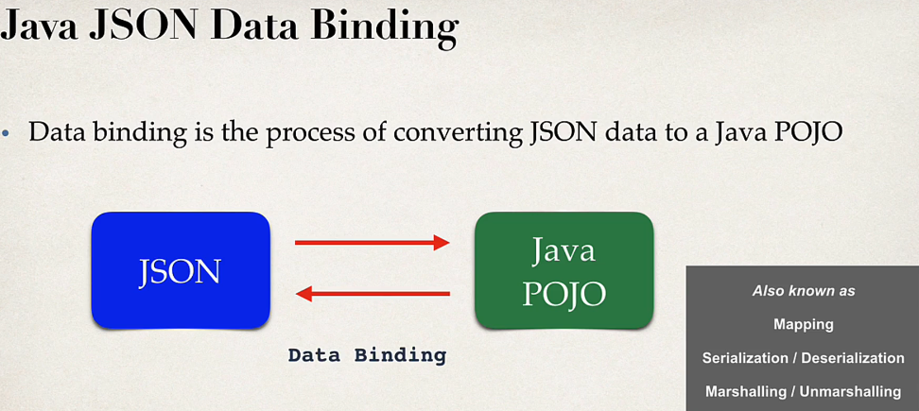

Jackso is mainly handled this data binding between json and java pojo

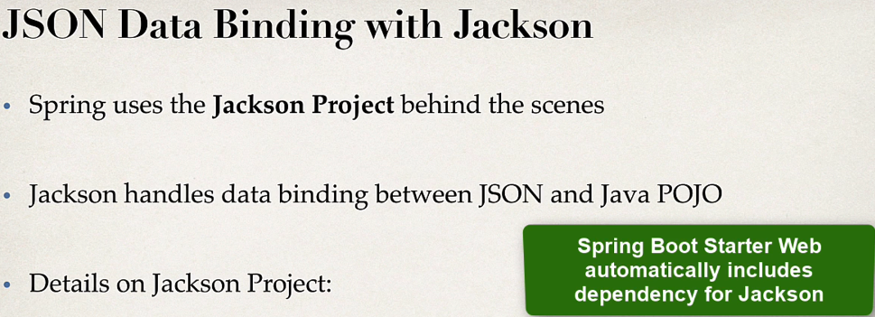

Jackson internally calls the pojo setter methods to populate the pojo class

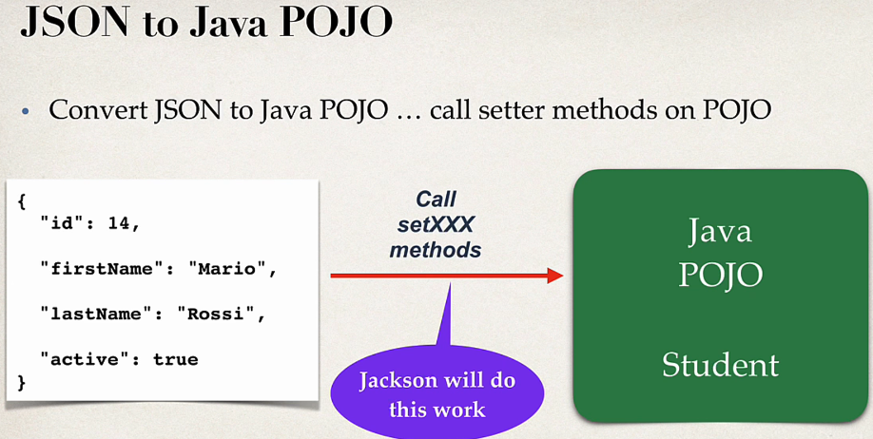

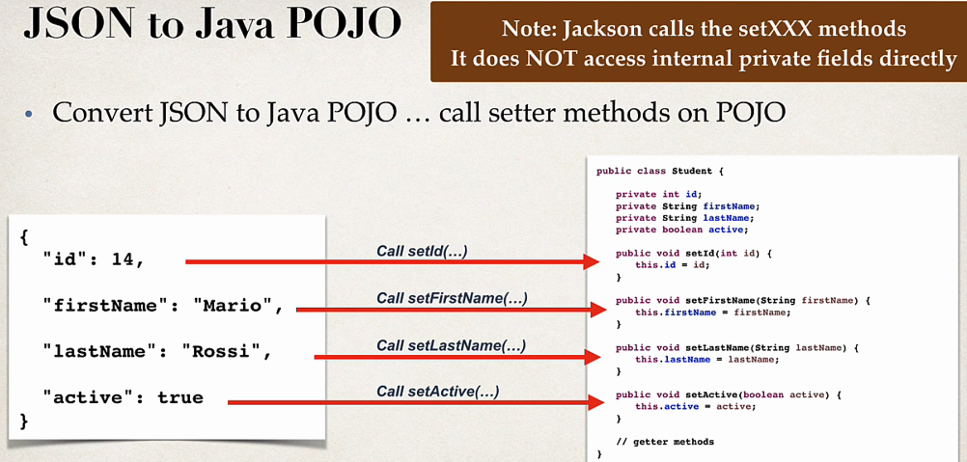

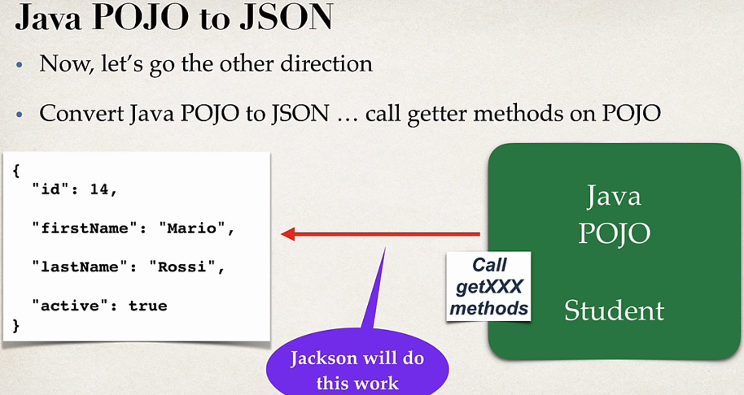

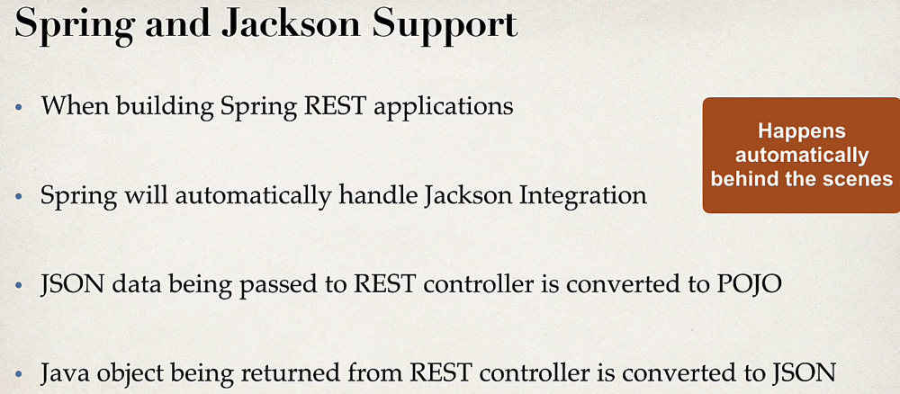

@PostContruct / @PreConstruct

Good use case is when we are testing rest req/res we need to initialize values with some list but we don’t want to create those values every time call happens, so we can use @PostConstruct so that it will be loaded only once when beans are created.

## **Exception handling in Spring REST**

**Using @ExceptionHandler in a controller**

It handles exception for a particular controller where it’s used

**Global Exception Handling**

In practical scenario large projects have multiple controller so need an global exception handling

It centralizes exception handling.

We can use **@Valid** from Jakarta or javax to validate using model class also

@PostMapping("/student")

**public** ResponseEntity<Student> saveStudent(**@Valid** @RequestBody Student student)

In Student class also method validations that we want to implement

@NotNull

@Size(min=2, message = "Name must have atleast two charecters")

**private** String name;

now handle the exception in global exception handling class with controller advice

@ExceptionHandler

**public** ResponseEntity<StudentErrorResponse> handleErrorResponse(MethodArgumentNotValidException exception)

{

StudentErrorResponse errorResponse = **new** StudentErrorResponse();

errorResponse.setStatus(HttpStatus.***BAD_REQUEST***.value());

/* returning field error not the error.getMessage cause we want our declared

* message to show on the screen

*/

errorResponse.setMessage(exception.getFieldError().getDefaultMessage());

errorResponse.setTimestamp(System.*currentTimeMillis*());

**return** **new** ResponseEntity<StudentErrorResponse>(errorResponse, HttpStatus.***BAD_REQUEST***);

}

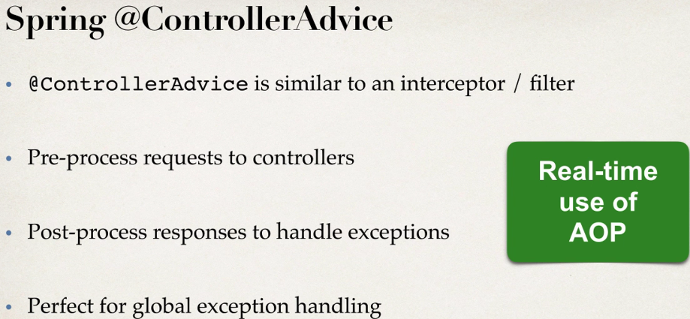

The Controller advice pre-process and post-process the requests and response, so any req to controller it pre-process and then when any exception happens it post process it and shows custom exception

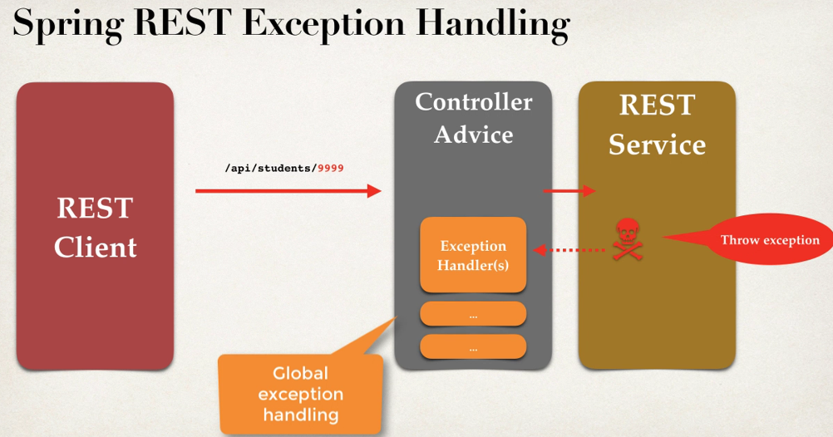

The code will be exactly the same just we need to remove the **exception handling code** ( @ExceptionHandler with method) to this new class with @ControllerAdvice and that’s it.

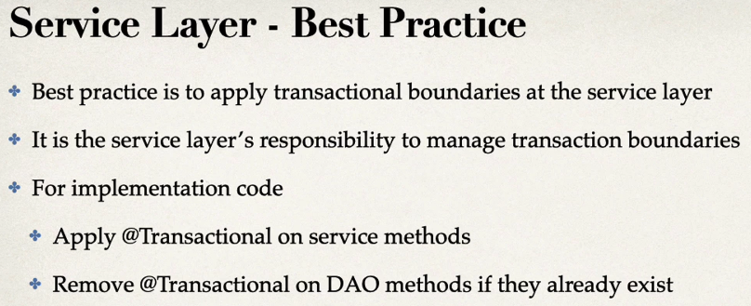

## **Spring Data JPA**

So we defined an interface for **employee DAO** and then we created an **employee DAO implementation**

and we wrote all of that code.

But now the question is what if we needed to create a DAO for another entity like customer, student, product, book?

Do we have to repeat all of the same code again? Because that's a lot of work just for one entity.

And one thing that you may have noticed with creating a DAO

So looking at this one method here, find by ID, most of the code is the same. The only difference is the entity type and primary key.

So here we have employee, employee, employee and the ID.

So employee is the entity type

and then the ID is the actual type of the primary key.

But if we wanted to use something else like product, book or customer, it's really the same thing.

And it would feel like a copy paste exercise to do this again and again for all these other entities.

And so they're really should be an easier way.

I'll simply plug in my entity type and primary key and spring will give me all of the basic CRUD features for free.

So basically, you create a DAO and you just plug in your entity type and you also plug in your primary key

and then Spring will give you a CRUD implementation without us providing the implementation code.

Well, this will actually help us minimize our boiler-plate DAO code.

**With Spring Data JPA no need to provide @Transactional since JPARepository provides it automatically.**

**For the repository interface is it necessary to add @Repository annotation?**

For Spring Data JPA repository interfaces, it’s not strictly necessary to add the @Repository annotation. Spring Data JPA provides the necessary infrastructure to recognize interfaces extending JpaRepository as repositories, and it automatically generates proxy instances for these interfaces. Therefore, adding @Repository to these interfaces is optional.

**Difference between CrudRepository and JpaRepository ?**

Both CrudRepository and JpaRepository are interfaces provided by Spring Data to simplify data access operations in a Spring application. They both offer basic CRUD (Create, Read, Update, Delete) operations, but there are some differences between them.

**CrudRepository:**

* CrudRepository is the most basic repository interface provided by Spring Data.
* It provides basic CRUD operations (save, findById, findAll, delete, etc.).
* Suitable for simple applications with straightforward data access requirements.

public interface YourEntityRepository extends CrudRepository<YourEntity, Long> {

// Additional custom queries if needed

}

**JpaRepository:**

* JpaRepository extends CrudRepository and adds additional JPA-specific features.
* It includes functionality such as pagination and the ability to flush the persistence context.
* Provides more powerful querying options through the use of the @Query annotation.
* Suitable for applications that require more advanced JPA features and complex query support.

## **Spring Data Rest**

If we want to further reduce the boiler plate code like for Employee we need to have employeeController, employeService and same e have to do for other entities also if required.

So with Spring Data Rest spring will automatically configure those endpoints for us by scanning for JPARepository.

The endpoints will be in plural of the entity name we provide in JPARepository.

<http://localhost:8080/employees>

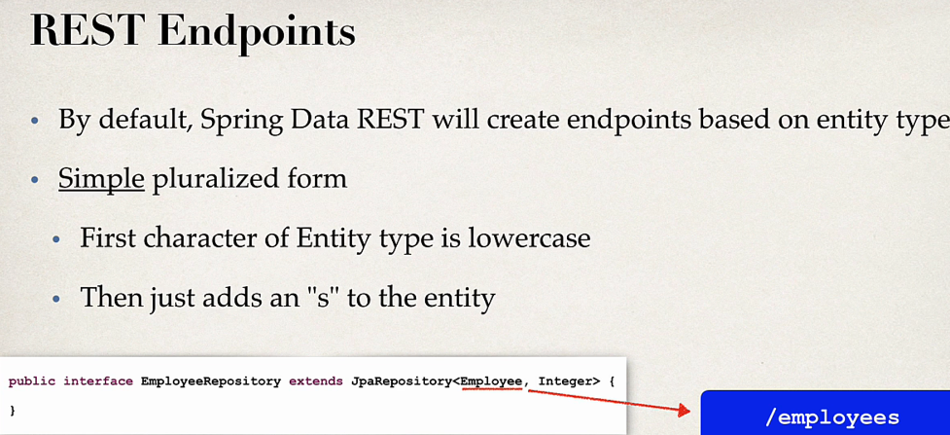

Spring Data Rest is good when we need basic operations , it’s not good enough when we have complex business logic.

## **Spring JPA Hibernate Relationships**

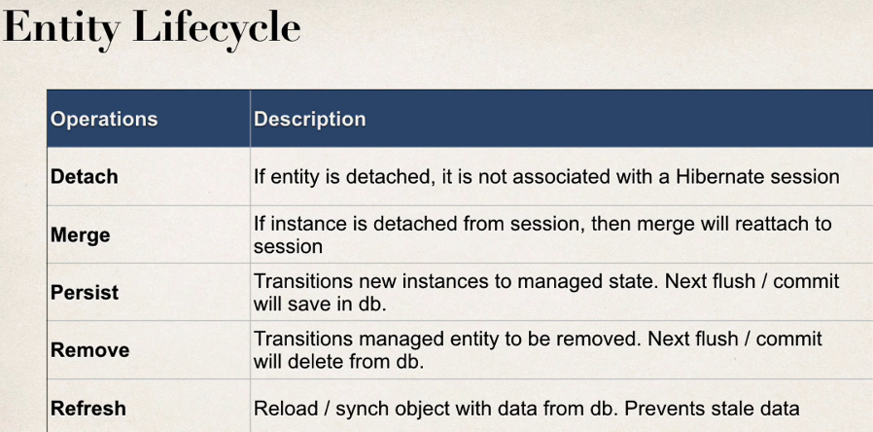

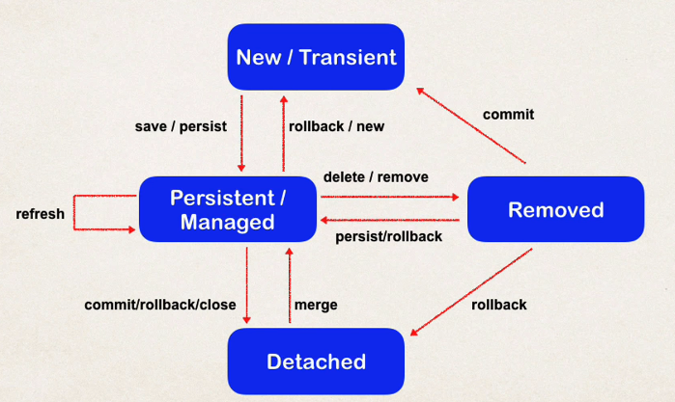

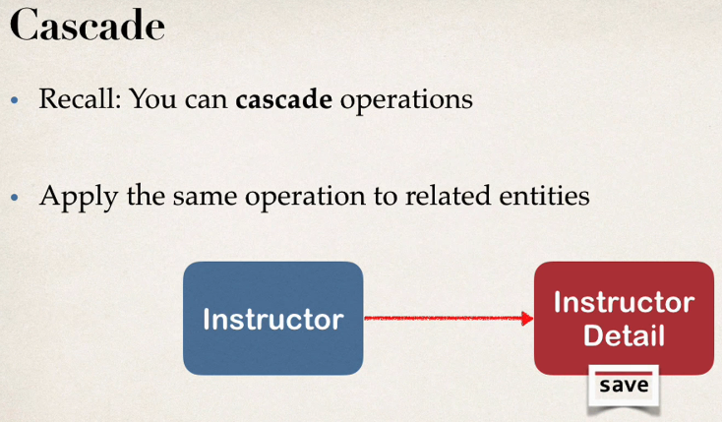

Without defining cascading when we save instructor it’s not going to save instructor details, so save instructor_detail when we save instructor need to define cascade operations that will be applied.

This **Instructor** and **Instructor_detail** table is having current **uni-directional** relation if we are only defining **@OneToOne** in Instructor entity class.

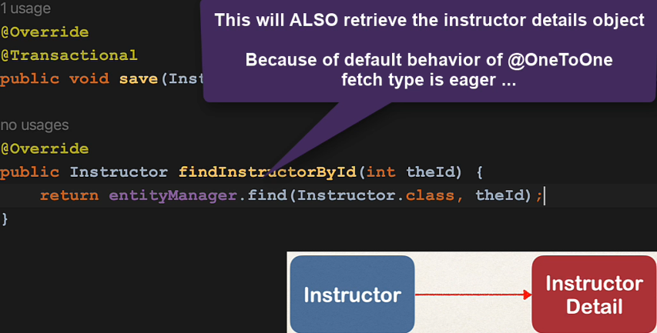

Bi-Directional relationship

To establish Bi-Directional relationship between Instructor and Instructor_detail we need to use @OneToOne in InstructorDetail entity also

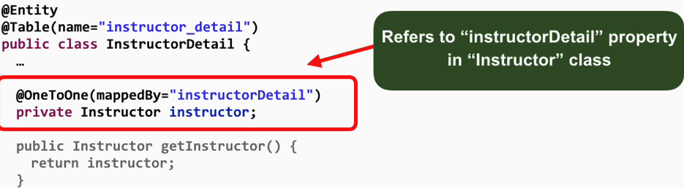

Here we will not use @JoinColumn as we already have that on Instructor entity so here we will mention **mappedBy= “ Instructor Class property name used for joining”**

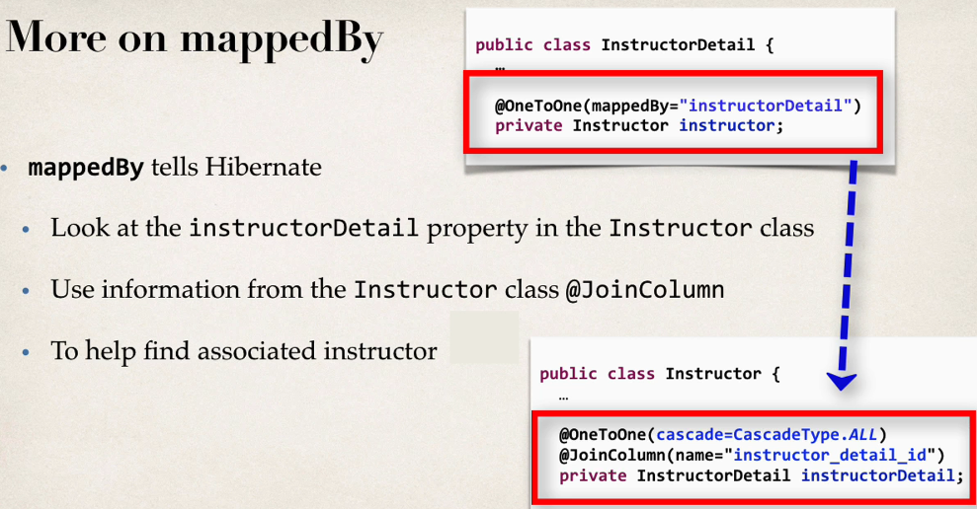

The owning side of foreign key must use @JoinColumn and the other side must use mappedBy

**If we don’t want to delete referenced** entity, then just add all the cascade types except **remove**

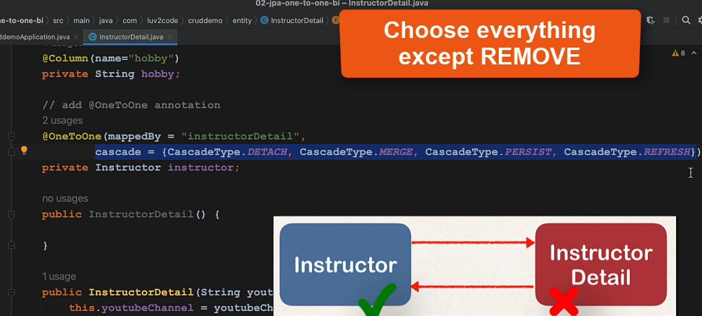

## **Eager vs Lazy loading**



By default OnetoOne will do **eager** fetching of data, means when we do findById for Instructor it will also fetch Instructor details data also.

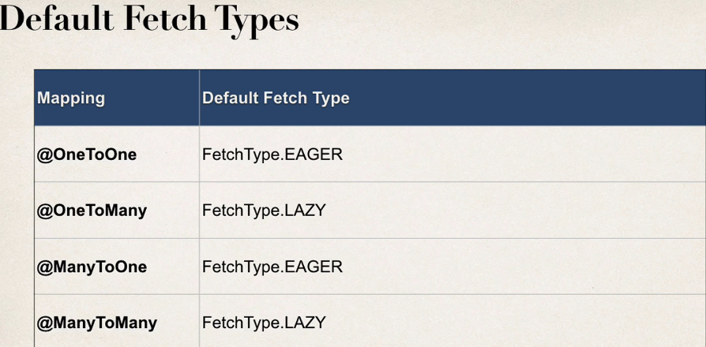

Relationship between Instructor and course is OneToMany as one instructor can have many courses and from course side it’s ManyToOne as many courses can have one instructor.

So, if we try to fetch Instructor with courses,

Public Instructor findInstructorWithCourse(int id)

{

repository.findById(id);

}

Instructor ins = findInstructorWithCourse(1);

System.out.println("Instructor data with id: "+id+" => "+ins); <= works fine

System.out.println("Instructor data with id: "+id+" => "+ins.getCourses()); <= this will throw error as we are doing lazy fetching

Hibernate session expired error will come if we try to fetch the courses.

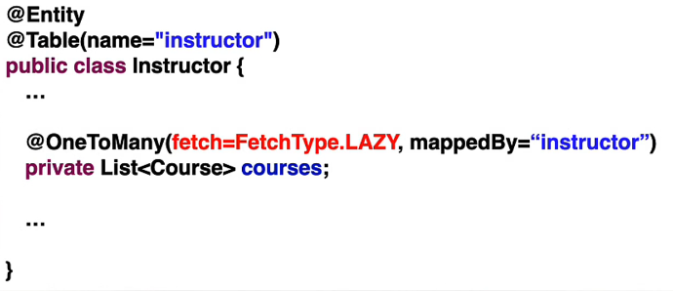

To solve this problem, fetch courses forthat Instructor id add attach to the Instructor obj

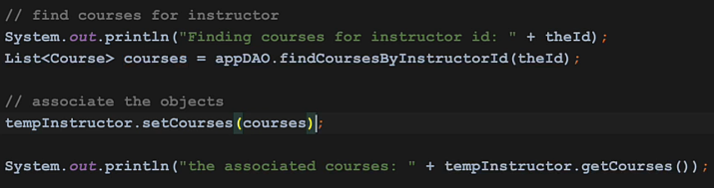

**ManyToMany Mapping**

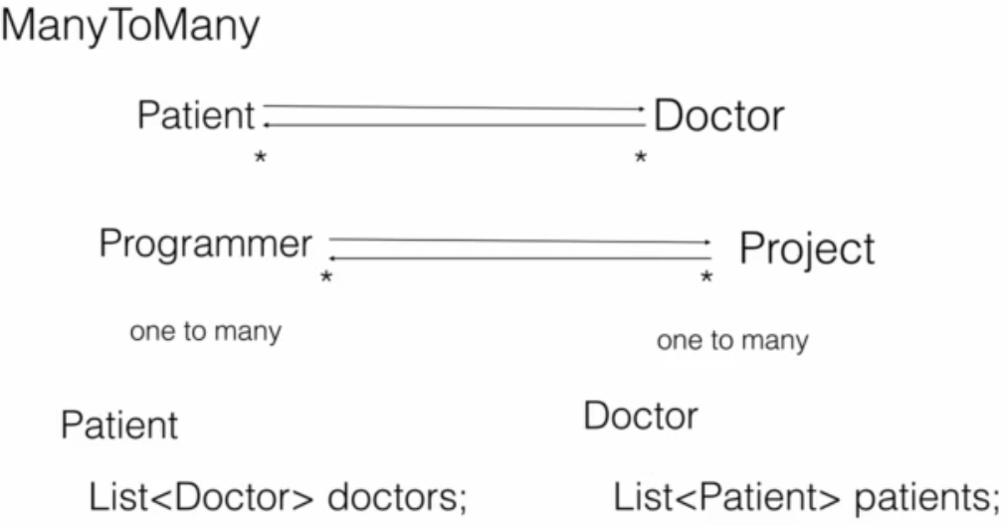

Use list on both entities for many to many relationships.

Like below we have courses and students, a course can have many students and a student can have many courses.

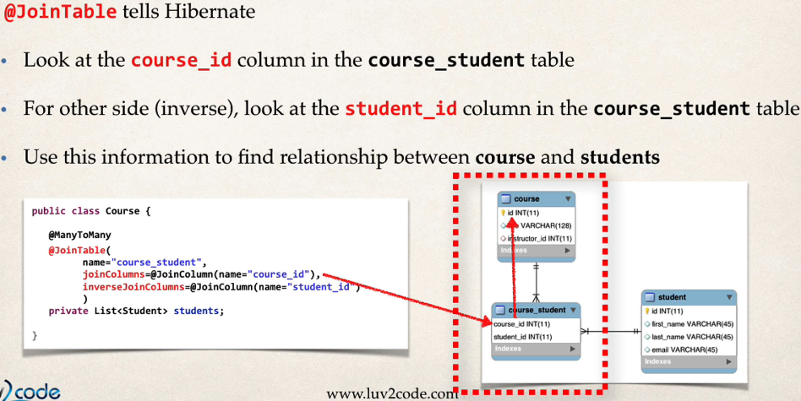

We can use mappedBy in student entity as usually we do

Or we can use ManyToMany again on student side as well, this will give more control over cascading and customization.  allowing you to customize it and specify cascade behavior explicitly.

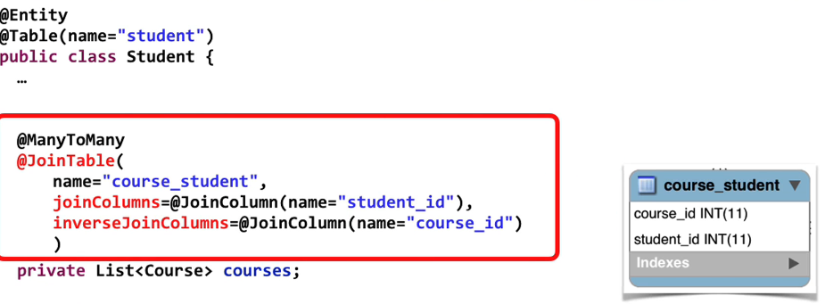

# **Spring MVC**

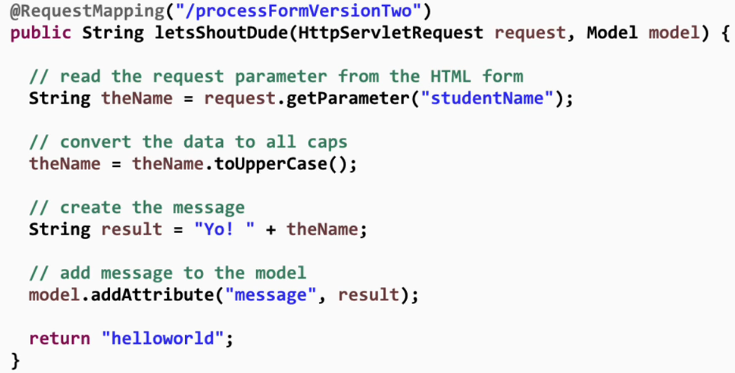

We can read param values using HttpRequestParam or we can use @Requestparam which spring provides

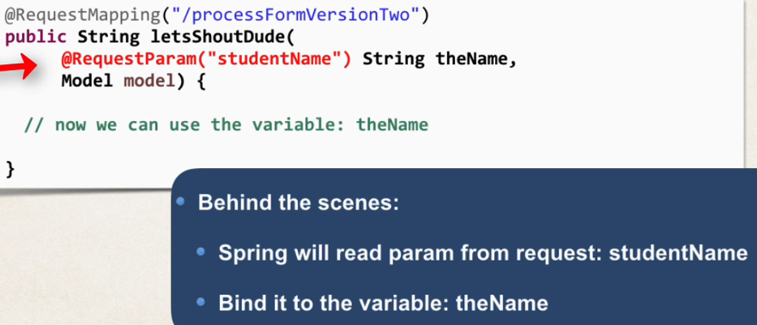

## **Validations**

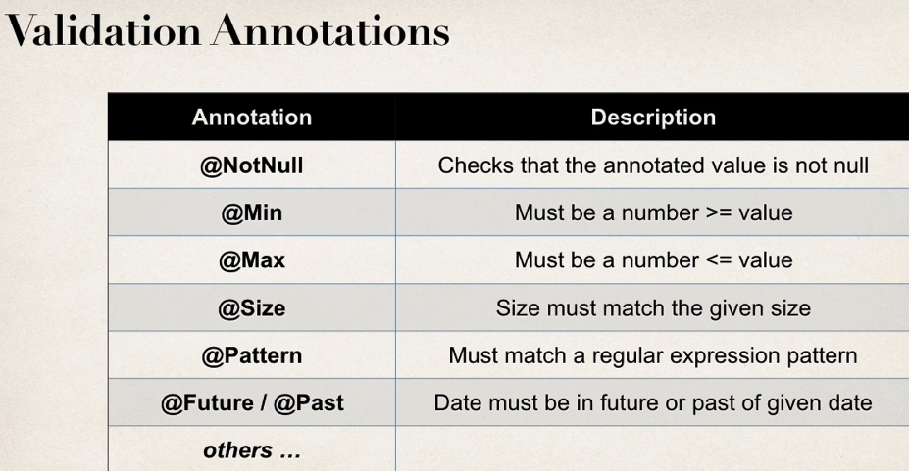

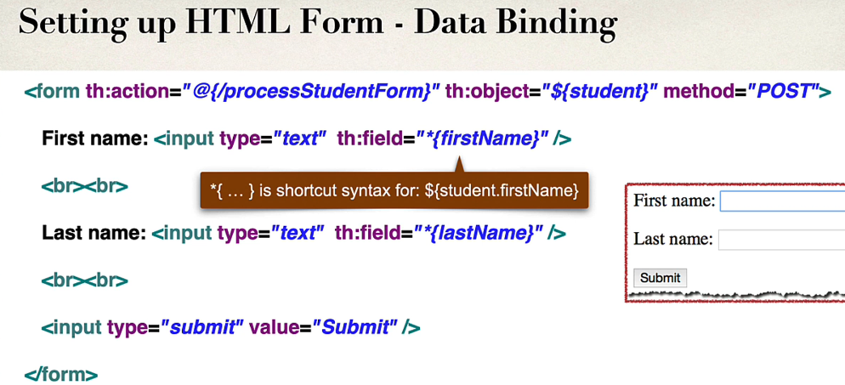

## **Swagger**

Swagger helps us to do API documentation of our rest API and helps to keep it up to date

No need to add swagger dependencies individually as swagger implements openAI doc specification so just add one dependency of springdoc for swagger ui and all.

<dependency>

<groupId>org.springdoc</groupId>

<artifactId>springdoc-openapi-starter-webmvc-ui</artifactId>

<version>2.3.0</version>

</dependency>

Note:

The springdoc-openapi-starter-webmvc-ui and springdoc-openapi-starter-webmvc-api dependencies only support JDK 17 and Spring Boot 3.x. If you want to use Spring Boot 2.x, please use springdoc-openapi-ui dependency.

To open **swagger ui** type: localhost:8080/swagger-ui.html

https://bell-sw.com/blog/documenting-rest-api-with-swagger-in-spring-boot-3/

**Project: RESTApiWithSwagger**

## **Work with both Json and XML**

If you’re looking for a mature, flexible way of supporting and working with both JSON and XML for the same data, the Jackson XML module is a fantastic library to leverage. It’s not only a solid way to go on its own, but it also has the added benefit of being able to mostly reuse the same configuration for both XML as well as JSON.

<dependency>

<groupId>com.fasterxml.jackson.dataformat</groupId>

<artifactId>jackson-dataformat-xml</artifactId>

<version>2.9.0</version>

</dependency>

# **Microservices**

Microservices are small restful loosely coupled deployable units which are cloud enabled.

## **Challenges with microservices:**

Complexity of the application increases.

Distributing the application into microservices can be challenging and problematic at first.

Need a proper monitoring of microservices and if some error happens which microservice is responsible for need to find that quickly.

Manage different configurations of different microservices.

## **Spring Cloud**

Spring cloud provides some solutions to these common problems of distributed systems.

Spring cloud is a collection of different projects ex: Spring Cloud Config, Spring Cloud Netflix

Spring cloud config helps to manage different configurations of different microservices in a centralized manner.

Advantages of Microservices

We can have each microservices in different technologies. It makes adaption to new technologies easy.

Dynamic scaling

Faster release cycles

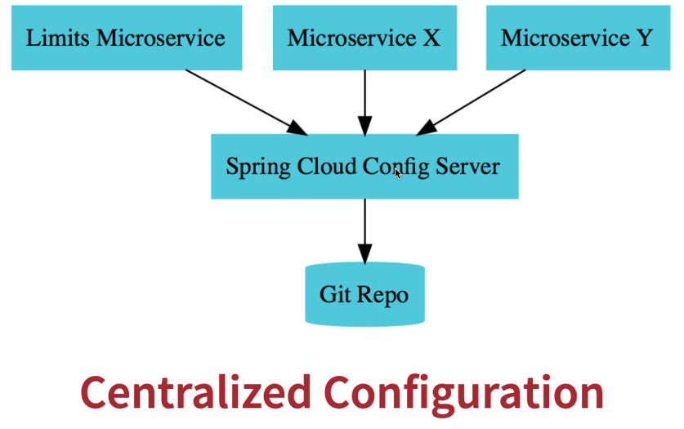

https://github.com/sovon9/Spring-Cloud-Config

@**EnableConfigServer**:

First we will start from using config from local application.properties.

**Limits-service**

This project will be used to fetch configuration and show as a rest json response

POM XML: **web, actuator, config-client**

* controller



* Now to use config from application properties :



The optional word is to not be getting exception if we don’t configure config server from the beginning. It will start the server without declaring or starting config server. We can remove **Optional** from the import after we created config server.

Also we are mentioning that when we declare the config server will be at port 8888

**LimitConfiguration**

We need a to bind with the properties in application properties. So we will be creating a class limitconfiguration to hold the values.



**@ConfigurationProperties** - Annotation for externalized configuration. Used to bind values from external property.

**LimitService**

This the model class for minimum and maximum values.



Postman : <http://localhost:8080/api/limit> <= this will return value

{

    "minimum": 10,

    "maximum": 900

}

**Link with Spring Cloud Config Server**

Create another project for spring cloud config server SPING-CLOUD-CONFIG

POM XML: **config server**

**Create git repo for storing configurations :**

Go to any folder location where you want to have the local repo configurations

Do **$**  **git init** <=in that folder

Create a properties file

**limit-service.properties** :

limit-service.min=100

limit-service.max=999

git add limit-service.properties

git commit -m "limitservice config"

Now we have to map this properties file with SPRING-CLOUD-CONFIG application.

* Add these lines to application.properties

spring.application.name=SPRING-CLOUD-CONFIG

server.port=8888

# adding git repo location for configuration

spring.cloud.config.server.git.uri=file:///c:/Users/890091/Documents/Git-LocalConfig-Repo

with the location address we have to add file:/// then the file location

check if the application able to pickup the configs by going: http://localhost:8888/limit-service/default

here limit-service is the properties file name and default is the profile

{

    "name": "limit-service",

    "profiles": [

        "default"

    ],

    "label": **null**,

    "version": "c1264f33f80051b99b4fc824e7fdcc512ae7f82f",

    "state": **null**,

    "propertySources": [

        {

            "name": "file:///c:/Users/890091/Documents/Git-LocalConfig-Repo/limit-service.properties",

            "source": {

                "limit-service.min": "100",

                "limit-service.max": "999"

            }

        }

    ]

}

Now go to Limits-service application and change the application name to :

spring.application.name=limit-service

changed from limits-service to limit -service as the **limits-service** application will try to fetch the config **using port number/application name/default**

**Why we have to change the application name?**

In general spring is expecting you to set the configuration file name to the same name of the application so it’s trying to pick with the same name.

To **configure a custom name** you need to add the property: spring.cloud.config.name=limit-service to the limits-service application.property

The Config Service serves property sources from **/{application}/{profile}/{label},** where the default bindings in the client app are as follows:

* "application" = ${spring.application.name}
* "profile" = ${spring.profiles.active} (actually Environment.getActiveProfiles())
* "label" = "master"

You can override all of them by setting spring.cloud.config.* (where * is name, profile or label)

### **Fetch configuration with profiles**

To use profile specific configurations need to create profile specific configuration properties files in config folder location

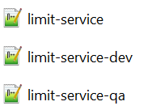

Use -(profile name) with file to declare it for that profile.

Now at **limit-service** application.properties just mention which profile needs to be use by

#set up profiles for config

spring.profiles.active=qa

or if it still fetches from default profile then have to use spring.cloud.config.profile=dev

### **Reload Configurations**

You will notice if you change anything in git config repository config server immediately picks it up but the client server that is limit service is still showing the old configurations. So for client app to pick it up you need to restart your client app.

Or you can refresh it through actuator endpoint: **/refresh**

## **Rest Template / Feign**

https://github.com/sovon9/MicroserviceCommunication-RestTemplate-Feign

### **What is Feign/ Feign Client in spring boot?**

Feign Client is a **Declarative REST Client** in Spring Boot Web Application. But what do you mean by Declarative REST Client? It means we need to specify the client specification as an Interface and Spring Boot will take care of the implementation for us.

The @EnableFeignClients annotation in Spring Cloud is used to enable the Feign client functionality in a Spring Boot application. When you apply this annotation to a configuration class or the main application class, it tells Spring to scan for interfaces annotated with @FeignClient and create the necessary proxy beans for them.

The **path** attribute in a @FeignClient annotation in Spring Cloud is used to specify a prefix that will be prepended to all request mappings defined in the associated interface. This can be useful when you want to group and organize related API endpoints under a common path.



## **Service registry / naming server**

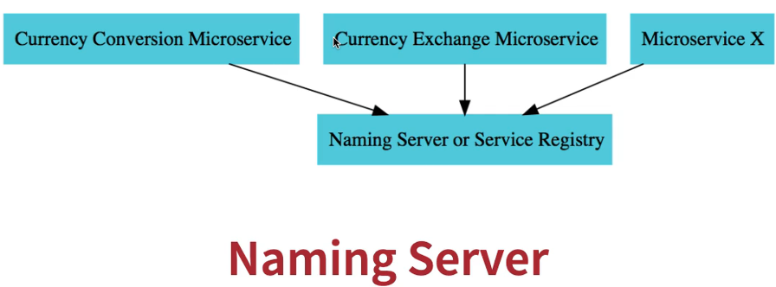

When currency conversion wants to talk to currency exchange then it will ask naming server/ service registry to give the address of currency exchange and naming server will return those a details to currency conversion service and then it will use those address to send request to currency exchange.

**Naming-Server** microservice for creating eureka server.

POM XML : **EurekaServer , actuator**

**@EnableEurekaServer**

To enable Eureka server in application we need to use @EnableEurekaServer



* To not register naming server with itself we need to add below properties.

eureka.client.register-with-eureka=false

eureka.client.fetch-registry=false

* To register microservices with this naming server need to add **Eureka Discovery Client** dependency to currency conversion and currency exchange.
* We can specify naming server url by eureka.client.serviceUrl.defaultZone=http://localhost:8761/eureka

## **Client Side Load Balancing**

Feign uses spring cloud load balancer internally to do client-side load balancing. It was added to the class path by spring-cloud-starter-netflix-client.

For load balancing we just need to remove url from @FeignClient so that it will talk to Eureka server for getting available Currency Exchange server to connect to.

//@FeignClient(name = "Currency-Exchange", url = "localhost:8080", path = "/currency-excahange")

@FeignClient(name = "Currency-Exchange", path = "/currency-excahange")

**public** **interface** CurrencyExchangeProxy{

@GetMapping("/from/{from}/to/{to}")

**public** CurrConvResponse getExcValue(@PathVariable String from, @PathVariable String to);

}

## **API-Gateway**

Microservices have a lot of common features like authentication, authorization, logging and where we should implement there features is the main question, so typically API gateway is used for these features.

API gateways sometimes also called as edge microservice

<https://www.youtube.com/watch?v=1vjOv_f9L8I&ab_channel=JavaBrains>

POM XML: add gateway dependency from starter.io and remove -mvc from starter-config

## **Circuit Breaker**

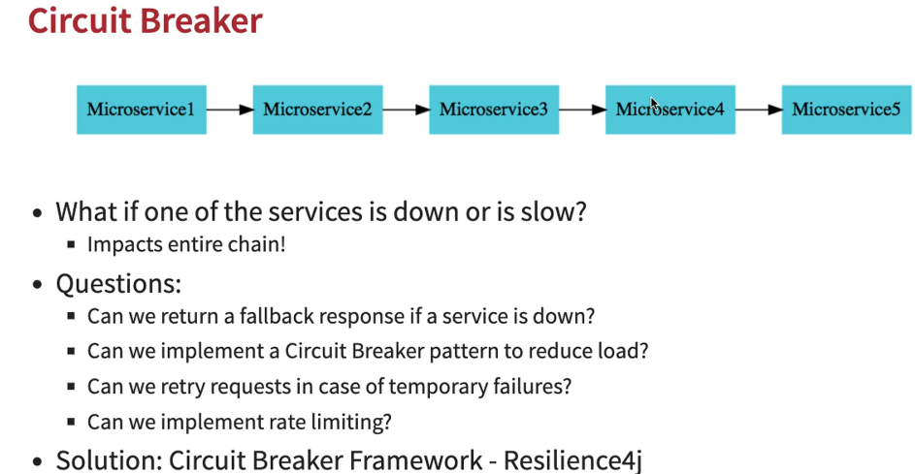

POM XML : add resilience4j dependency from started.io

In a controller we can annotate a method with @Retry for retrying in case of failure

@Retry(name="p1-retry", fallbackMethod = "fallbackResponse")

@GetMapping("/testcircuitbreak")

**public** String getTestAPIRes()

{

logger.error("******** trying to connect to localhost:8888 *****************");

ResponseEntity<String> res = **new** RestTemplate().getForEntity("http://localhost:8888", String.**class**);

**return** res.getBody();

}

/**

* fallback method accepts a parameter that extends throwable/ of type throwable

* based on the exception we can send different response back

*/

**public** String fallbackResponse(ResourceAccessException exception)

{

**return** "**** Server not found or took too long to respond ****"+exception.getMessage();

}

In Retry the name specifies which instance to use.

We can create instances in application.properties

resilience4j.retry.instances.p1-retry.maxAttempts=4

we can set wait time between attempts by

resilience4j.retry.instances.p1-retry.waitDuration=1s

To increase wait time exponentially,

resilience4j.retry.instances.p1-retry.enableExponentialBackoff=true

After to specified no of attempts if the resource still not available then we can return a fallback response by the **fallbackMethod** parameter in @Retry

We also have to declare a method with that method name with a of throwable type parameter like exceptions.

### **Rate limiter**

Rate limiter defines no of call allowed in a limited period of time.

@RateLimiter(name = "r1-ratelimit")

@Bulkhead(name = "r1-bulkhead")

@GetMapping("/ratelimiter")

**public** String getRateLimiterTest()

{

**return** "************* rate-limiter test **************";

}

Application.properties

#configure ratelimiter

resilience4j.ratelimiter.instances.r1-ratelimit.limitForPeriod=2 <=no of calls

resilience4j.ratelimiter.instances.r1-ratelimit.limitRefreshPeriod=10s <= within this time

### **Bulkhead**

It defines maximum concurrent calls allowed.

#bulkhead configuration

resilience4j.bulkhead.instances.r1-bulkhead.maxConcurrentCalls=4

# **Docker**

Docker hub(hub.docker.com) is called a docker registry.

A registry contains a number of repositories. It contains a number of images.

Repository holds the images, image is a static version.

Images are kind of blueprint/specification on how the containers can be created. Multiple containers can be created with an image.

Running version of an image is called a container. (image is just like a class and container is an object)

Docker engine runs and manages the docker containers.

Docker file contains all the specifications to create a docker image.

To run a docker image type: 

It will download the docker image and run the local image with all container ports unexposed.

Everything you run in a container runs in an internal docker network, no ports are accessible.

To expose a port





Whenever you close your terminal the app server also stops. To make it run in the background and not attached to the terminal, 

**-d stands for detach mode**

Main difference between docker and virtual machine

Virtual machines are having guest OS on top of the system OS where it’s running, so two OS makes this architecture heavy.

In docker there is only one OS that is the system OS where docker engine is installed and docker engine takes care of all the container running with images and images are loaded with all the necessary data.

* A docker image can have multiple tags

## **To check a image history**

To check an history of an image type: $ docker image (image-name) or (image-id)

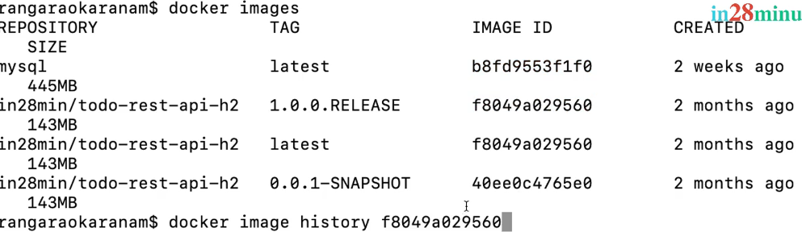

## **To inspect an Image**

To inspect an image type : $ docker image inspect (image-name) or (image-id)

Inspect tells in detail in json format that what docker version, port, configs, java version were used in create this image.

## **To remove an image from Local**

To remove an image type : $ docker image remove (image-name) or (image-id)

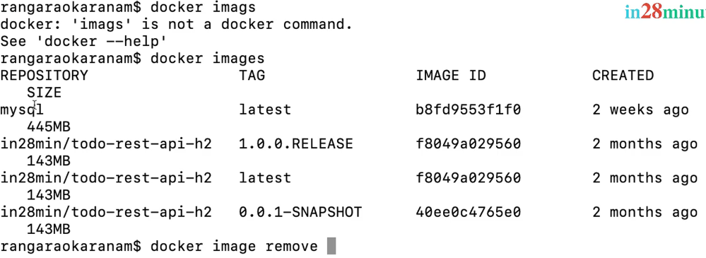

## **Pull an image**

$docker pull mysql

## **Check Logs**

$ docker logs -f (container-name) or (container-id)

-f for following the logs

## **Show all containers present**

$ docker container ls <= shows all the **running** containers

$ docker container ls -a <= shows all the containers

## **Pause and Unpause a container**

If a server is running in a container and you pause it you will not able to access the server until you unpause it but the server is not actually stopped. Pause stops the container at that specific state.



## **Prune docker containers**

If you check $docker container it will show all the available containers, there you can see all the stopped containers also, to remove stopped containers use prune

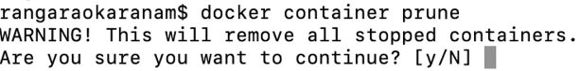

## **Stop vs kill Containers**

$ docker container stop (container-name) or (container-id)

Stop stops the container but not immediately , it gives time to shutdown required resources.

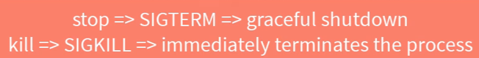

But kill immediately stops the container, so it’s not recommended most of the times.

## **Restart docker container automatically with starting of Docker desktop**

To restart automatically an container type : $ docker run -p (port-number) -d --restart=always (container name)….

--restart is declaring a restart policy

By default, restart policy is no

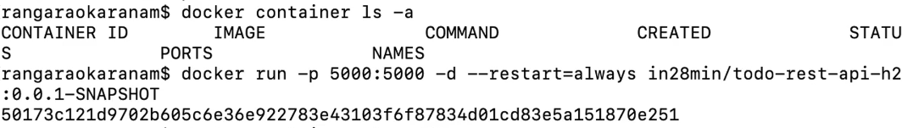

So even if you stop or accidentally docker desktop stops it will again start automatically when docker desktop starts up as it will starch for any container with policy restart.

## **Docker Events**

It shows all the events happening in docker.

$ docker events

## **Docker Stats**

It will show all the stats of containers running

$ docker stats

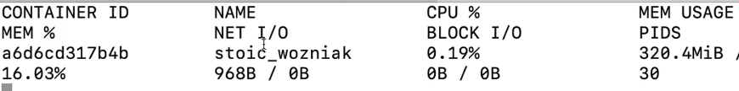

## **Run docker containers with certain cpu and memory limit**

-m specifies memory limit and –cpu-quota specifies cpu quota, in docker 100% cpu = 100000



**Docker system -df**

Shows system information of docker, how many images have been loaded, no of containers present etc..

Create a Docker Image

Paketo provides all the base packages for packing our application for creating a docker image in spring boot

Packaging Microservices with Docker

With spring boot you can natively build images with Docker as long as you have maven plugin in you POM.XML. Add below config to give an image name.

# **Distributed Tracing**

Distributed tracing enables you to trace a request from start to end.

It helps in request visualization that is what’d happening to a request and how it’s traversing in different services. It helps to identify a problem with a request, how long it’s taking to process and where it’s having problems, how it’s interacting with different services, It helps in error analysis and debugging.

It also helps to optimize the performance by tracing where a request taking time.

## **Zipkin**

Zipkin is an open-source distributed tracing system.

Microservice applications will send data to collectors which send it to storage for storing the trace data.

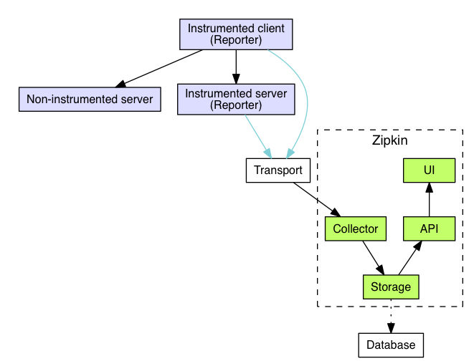

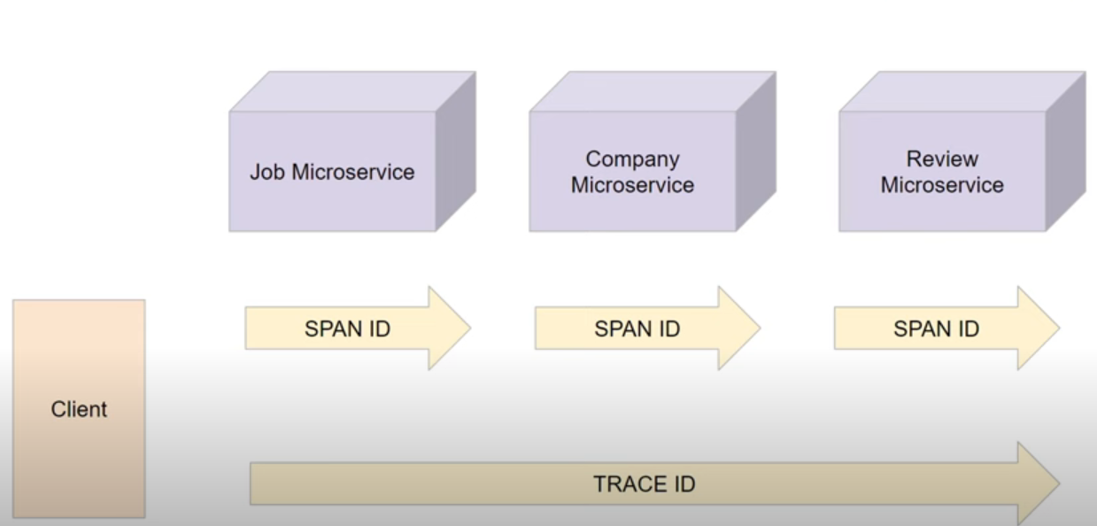

Trace ID : a request from client that traversing through multiple microservices. It is set of spans that share a single root span. Traces are built by collecting all Spans that share a traceId. The spans are then arranged in a tree based on spanId and parentId thus providing an overview of the path a request takes through the system.

Span ID : A span is a single-host view of an operation. A trace is a series of spans (often RPC calls) which nest to form a latency tree. Spans are in the same trace when they share the same trace ID

Trace ID is at parent level and span is at each microservice level.

## **Micrometer**

It provides insights of your application that helps understanding the performance.

Collects metrics of application of resource utilization and etc.

Feign-micrometer:

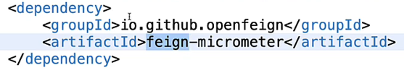

Only for spring boot 3 and above with open feign connections in microservices will not able to trace.

We need additional dependency feign-micrometer to trace it through feign proxy requests.

Also if you are using restTemplate for microservice communication then make sure you have autowired restTemplate not just **new RestTemplate().getEntity(…… otherwise you will not see the full trace.**

Or use Builder pattern,

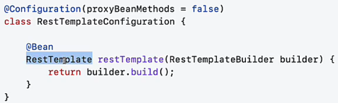

# **Practice questions**

Difference between checked exception and unchecked exception

How developer tool works in spring?

Best alog for storing password ?

Ans : bcrypt

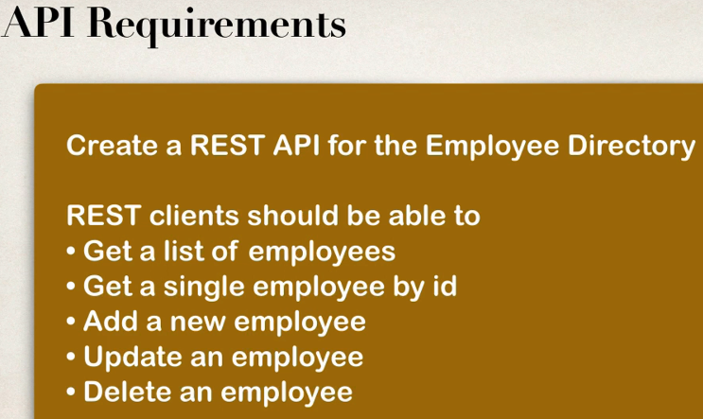

* Create a course and instructor with OneToMany, ManyToOne mapping and perform CURD operations, but don’t delete Instructor when course got deleted and vice versa.